21BDS0340

Abhinav Dinesh Srivatsa

Database Systems Lab

Assignment – V

Exercise – V

1. Find the employee who is getting the highest salary in the research department

Command:

select f_name, m_name, l_name from employee_bds0340 where salary = (select max(salary) from employee_bds0340 e join department_bds0340 d on e.dept = d.num where d.name = 'Research');

Output:



1. Find the employees who earn the same salary as the minimum salary for each department

Command:

select f_name, m_name, l_name from employee_bds0340 where salary in (select min(salary) from employee_bds0340 group by dept);

Output:

1. Find the employee whose salary is greater than the average salary of department 2

Command:

select f_name, m_name, l_name from employee_bds0340 where salary > (select avg(salary) from employee_bds0340 where dept = 2);

Output:



1. List out all the department names with their individual employee strength

Command:

select d.name, count(e.f_name) from department_bds0340 d join employee_bds0340 e on d.num = e.dept group by d.name;

Output:

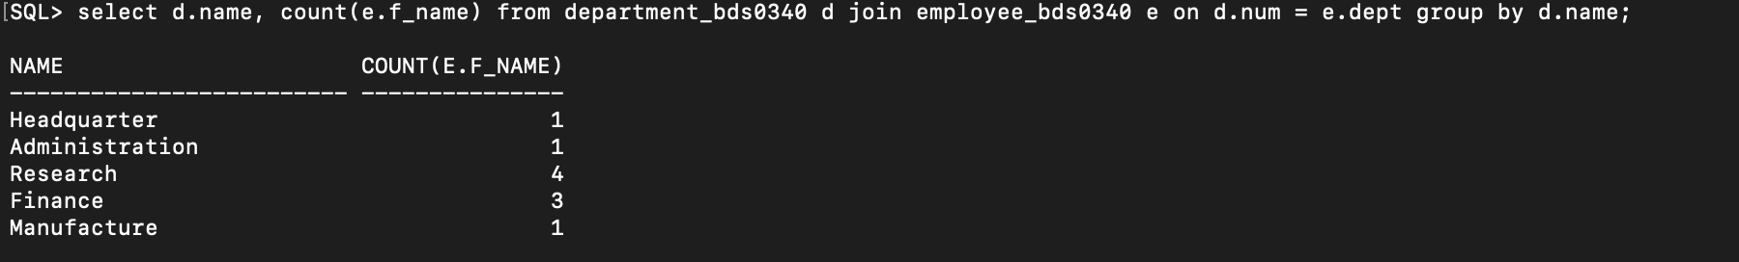

1. Find out the department name having the highest employee strength

Command:

select name from department_bds0340 where num = (select dept from employee_bds0340 group by dept order by count(*) desc fetch first 1 row only);

Output:



1. List out all the departments and average salary drawn by their employees

Command:

select d.name, avg(e.salary) from department_bds0340 d join employee_bds0340 e on d.num = e.dept group by d.name;

Output:

1. Find the maximum salary for each department

Command:

select d.name, max(e.salary) from employee_bds0340 e join department_bds0340 d on e.dept = d.num group by d.name;

Output:

1. Create a view to display the employee details who is working in IT department (IT does not exist, finding for Administration)

Command:

select e.* from employee_bds0340 e join department_bds0340 d on e.dept = d.num where d.name = 'Administration';

Output:



1. Create a logical table to store employee details who is getting salary more than 10000

Command:

create table high_salary_emp_bds0340( f_name varchar(25) not null, m_name varchar(1), l_name varchar(25) not null, ssn number(9) not null primary key, bday Date, address varchar(50), sex varchar(1) check (sex in ('M', 'F', 'm', 'f')), salary number(6) default 800, super_ssn number(9), dept number(1), constraint emp_sup_ssn_fk10 foreign key (super_ssn) references employee_bds0340 (ssn) on delete set null, constraint dept_fk10 foreign key (dept) references department_bds0340 (num) on delete cascade );

insert into high_salary_emp_bds0340 (f_name, m_name, l_name, ssn, bday, address, sex, salary, super_ssn, dept) select * from employee_bds0340 where salary > 10000;

select * from high_salary_emp_bds0340;

Output:

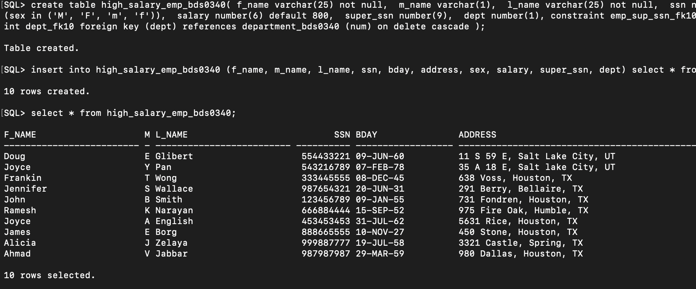

1. Create a table to store the employee details based on department number

Command:

create table dept_bds0340( f_name varchar(25) not null, m_name varchar(1), l_name varchar(25) not null, ssn number(9) not null primary key, bday Date, address varchar(50), sex varchar(1), salary number(6) default 800, super_ssn number(9), dept_name varchar(15));

insert into dept_bds0340(f_name, m_name, l_name, ssn, bday, address, sex, salary, super_ssn, dept_name) select e.f_name, e.m_name, e.l_name, e.ssn, e.bday, e.address, e.sex, e.salary, e.super_ssn, d.name from employee_bds0340 e join department_bds0340 d on e.dept = d.num;

select * from dept_bds0340;

Output:

